Ex. No. : 01D Date: 28.01.2026
Register No.: 231701046 Name: Sam Sundar

Temperature Convertor
Aim:
Create an app that converts temperatures between Celsius and Fahrenheit. Users can enter a temperature in an EditText, press a Button to perform the conversion, and see the result in a TextView.

Procedure:
- Create a New Android Project
  - Open Android Studio.
  - Select New Project → Empty Activity.
  - Enter the application name as Experiment4_MADD_46.
  - Choose Kotlin as the programming language.
  - Click Finish.
- Configure AndroidManifest.xml
  - Open AndroidManifest.xml.
  - Declare MainActivity inside the <application> tag.
  - Add MAIN action and LAUNCHER category so that the app starts from MainActivity.
  - Set the application theme.
- Design the User Interface
  - Open activity_main.xml.
  - Use a LinearLayout with vertical orientation and padding.
  - Add an EditText to enter the temperature value.
  - Add a RadioGroup with two RadioButtons:
    - To Fahrenheit
    - To Celsius
  - Set one RadioButton as default selected.
  - Add a Convert button.
  - Add a TextView to display the converted result.
- Implement the Kotlin Code
  - Open MainActivity.kt.
  - Load the layout using setContentView().
  - Access all UI components using findViewById().
  - Set an OnClickListener for the Convert button.
  - Validate input to ensure temperature value is entered.
  - Perform conversion based on selected RadioButton:
    - Celsius to Fahrenheit:
$$F=(C×9/5)+32$$
    - Fahrenheit to Celsius:
$$C=(F-32)×5/9$$
  - Display the converted temperature in the TextView.
- Run the Application
  - Connect an Android emulator or physical device.
  - Click Run ▶ in Android Studio.
  - Launch the application.
- Verify the Output
  - Enter a temperature value.
  - Select the required conversion type.
  - Click Convert.
  - The converted temperature is displayed on the screen.
  - If input is empty, an error message is shown.

AndroidManifest.xml

<?xml version="1.0" encoding="utf-8"?>
<manifest xmlns:android="http://schemas.android.com/apk/res/android"
xmlns:tools="http://schemas.android.com/tools">
<application
android:allowBackup="true"
android:dataExtractionRules="@xml/data_extraction_rules"
android:fullBackupContent="@xml/backup_rules"
android:icon="@mipmap/ic_launcher"
android:label="@string/app_name"
android:roundIcon="@mipmap/ic_launcher_round"
android:supportsRtl="true"
android:theme="@style/Theme.Experiment4_MADD_46">
<activity
android:name=".MainActivity"
android:exported="true">
<intent-filter>
<action android:name="android.intent.action.MAIN" />
<category android:name="android.intent.category.LAUNCHER" />
</intent-filter>
</activity>
</application>
</manifest>

Activity_main.xml

<?xml version="1.0" encoding="utf-8"?>
<LinearLayout xmlns:android="http://schemas.android.com/apk/res/android"
android:layout_width="match_parent"
android:layout_height="match_parent"
android:orientation="vertical"
android:padding="16dp">
<EditText
android:id="@+id/etTemp"
android:layout_width="match_parent"
android:layout_height="wrap_content"
android:hint="Enter temperature"
android:inputType="numberDecimal"/>
<RadioGroup
android:id="@+id/rgConversion"
android:layout_width="wrap_content"
android:layout_height="wrap_content"
android:orientation="horizontal"
android:layout_marginTop="16dp">
<RadioButton
android:id="@+id/rbCtoF"
android:layout_width="wrap_content"
android:layout_height="wrap_content"
android:text="To Fahrenheit"
android:checked="true"/>
<RadioButton
android:id="@+id/rbFtoC"
android:layout_width="wrap_content"
android:layout_height="wrap_content"
android:text="To Celsius"/>
</RadioGroup>
<Button
android:id="@+id/btnConvert"
android:layout_width="wrap_content"
android:layout_height="wrap_content"
android:text="Convert"
android:layout_marginTop="16dp"/>
<TextView
android:id="@+id/tvResult"
android:layout_width="wrap_content"
android:layout_height="wrap_content"
android:text="Result: "
android:textSize="18sp"
android:layout_marginTop="16dp"/>
</LinearLayout>

MainActivity.kt

package com.example.experiment_4_madd_46
import androidx.appcompat.app.AppCompatActivity
import android.os.Bundle
import android.widget.*
class MainActivity : AppCompatActivity() {
override fun onCreate(savedInstanceState: Bundle?) {
super.onCreate(savedInstanceState)
setContentView(R.layout.activity_main)
val etTemp = findViewById<EditText>(R.id.etTemp)
val rbCtoF = findViewById<RadioButton>(R.id.rbCtoF)
val rbFtoC = findViewById<RadioButton>(R.id.rbFtoC)
val btnConvert = findViewById<Button>(R.id.btnConvert)
val tvResult = findViewById<TextView>(R.id.tvResult)
btnConvert.setOnClickListener {
val tempText = etTemp.text.toString()
if (tempText.isEmpty()) {
tvResult.text = "Please enter a temperature"
} else {
val temp = tempText.toDouble()
if (rbCtoF.isChecked) {
val result = (temp * 9 / 5) + 32
tvResult.text = "Result: $result °F"
} else if (rbFtoC.isChecked) {
val result = (temp - 32) * 5 / 9
tvResult.text = "Result: $result °C"
}
}
}
}
}

Output:

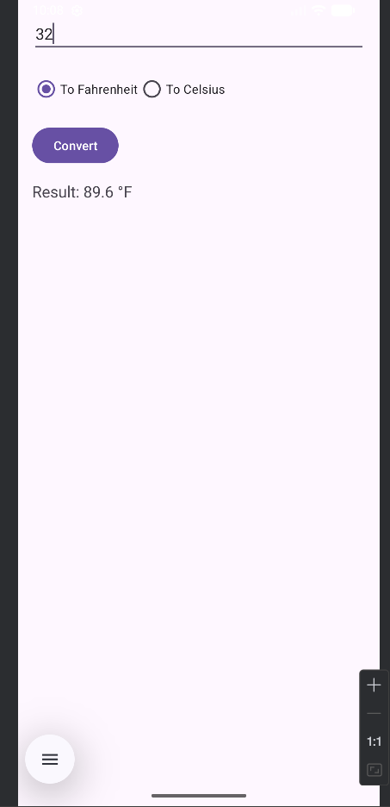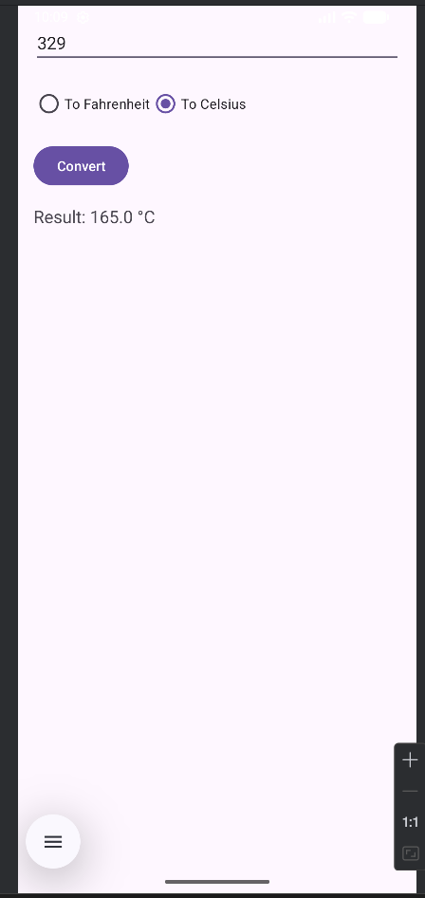

Result:
The Android application was successfully developed to convert temperature values between Celsius and Fahrenheit using RadioButtons and Button click events.

